//end module

Q1.

//Q1

#include<stdio.h>

void main(){

char str[]="aei zpo 12";

int v=0,c=0,s=0,d=0;

for(int i=0;str[i]!='\0';i++){

if(str[i]=='a'||str[i]=='A'||

str[i]=='e'||str[i]=='E'||

str[i]=='i'||str[i]=='I'||

str[i]=='o'||str[i]=='O'||

str[i]=='u'||str[i]=='U'){

v++;

//printf("V:%d\n",v);

}

else{

if(str[i]==' '){

s++;

//printf("S:%d\n",s);

}

else{

if(str[i]>='A'&&str[i]<='Z' || str[i]>='a'&& str[i]<='z'){

c++;

//printf("C:%d\n",c);

}

else{

if(str[i]>='0' && str[i]<='9'){

d++;

// printf("D:%d\n",d);

}

}

}

}

}

printf("Str:%s\n",str);

printf("vowels:%d consonants:%d space:%d digits:%d",v,c,s,d );

}

o/p

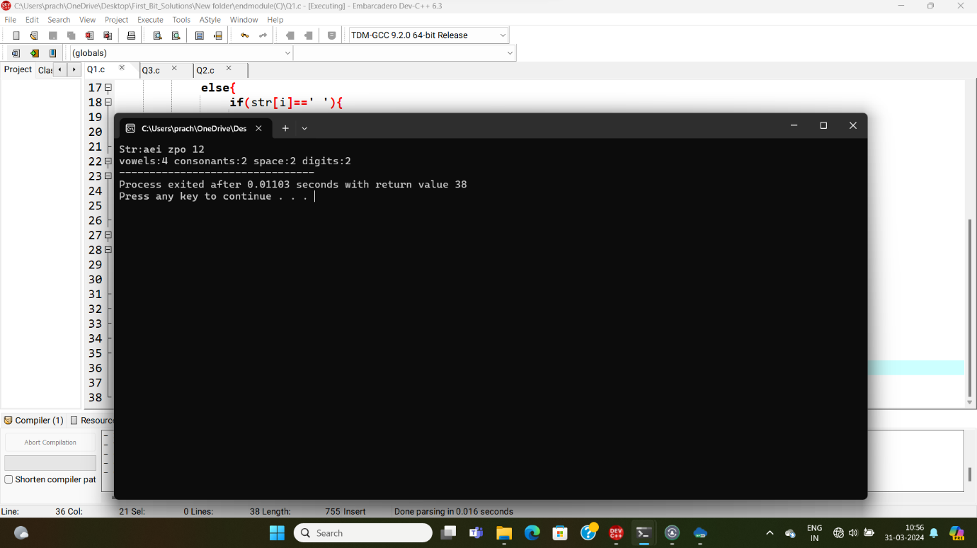

//Q2

//Q2

#include<stdio.h>

#include<math.h>

void main(){

int no;

printf("Enter the no to reverse:");

scanf("%d",&no);

int rev=func_rev(no);

printf("After reverse :%d",rev);

}

int func_rev(no){

if(no==0){

return 0;

}

else{

int count=0,c,power,num=no;

while(num!=0){

num=num/10;

count++;

}

c=count-1;

power=pow(10,c);

return ((no%10)*power )+func_rev(no/10);

}

}

//o/p

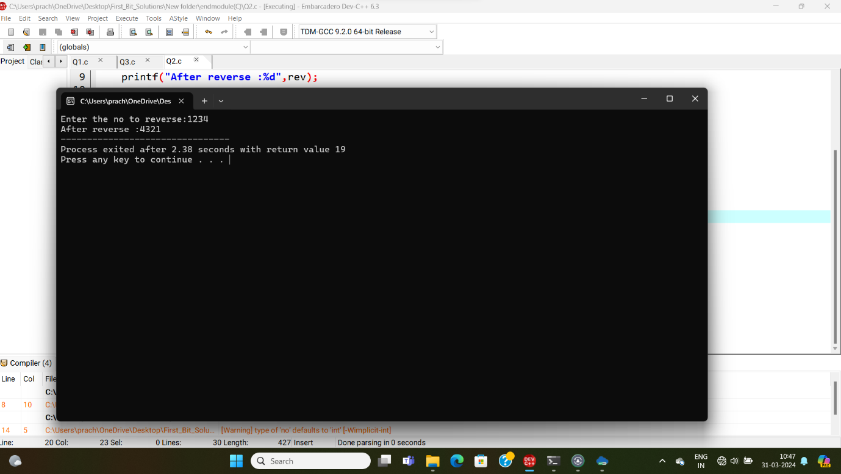

//Q3

//Q3

#include<stdio.h>

typedef struct product{

int id;

char name[20];

double price;

}product;

void display(product*,int);

void store(product*,int);

void main(){

product p[5];

store(p,5);

display(p,5);

}

void store(product* p,int s){

double dis;

for(int i=0;i<s;i++){

printf("\nEnter the value at index:%d\n",i);

printf("Enter the id:");

scanf("%d",&p[i].id);

fflush(stdin);

printf("Enter tha name");

gets(p[i].name);

printf("Enter the price:");

scanf("%lf",&p[i].price);

if(p[i].price>500){

dis=p[i].price*0.2;

printf("\nDiscount is %lf\n",dis);

p[i].price=p[i].price-dis;

printf("\nafter discount Price:RS.%lf\n",p[i].price);

}

else{

dis=p[i].price*0.05;

printf("\nDiscount is:RS. %lf\n",dis);

p[i].price=p[i].price-dis;

printf("\nafter discount Price:RS.%lf\n",p[i].price);

}

}

printf("\n");

}

void display(product* p,int s){

double gst,total=0;

for(int i=0;i<s;i++){

printf("product at index %d\n",i);

printf("id:%d\n",p[i].id);

printf("name:%s\n",p[i].name);

printf("Price:%lf\n",p[i].price);

total=total+p[i].price;

printf("\n");

}

printf("Total before gst:RS.%lf\n",total);

gst=total*0.18;

printf("Gst:RS.%lf",gst);

total=total-gst;

printf("Total after gst:RS.%lf\n",total);

}

